

Students, please place your name in this box

Semester 1 Examination

Question/Answer Booklet

PHYSICAL EDUCATION STUDIES STAGE 2
Belridge SHS

Time allowed for this paper
Reading time before commencing work: ten minutes
Working time for paper: two and a half hours

Materials required/recommended for this paper
To be provided by the supervisor
This Question/Answer Booklet
Multiple-Choice Answer Sheet
Question Sheet for Section Three (inside the front cover of this Question/Answer Booklet)

To be provided by the candidate
Standard items: pens, pencils, eraser, correction fluid, ruler, highlighters
Special items: non-programmable calculator

Important note to candidates
No other items may be taken into the examination room. It is your responsibility to ensure that
you do not have any unauthorised notes or other items of a non-personal nature in the
examination room. If you have any unauthorised material with you, hand it to the supervisor
before reading any further.

Structure of this paper

Section | Number of questions available | No. of questions to be attempted | Suggested working time (minutes) | Marks available
Section One:  Multiple-Choice | 20 | 20 | 30 | 20
Section Two:  Short Answer | 8 | 8 | 75 | 50
Section Three:  Extended Answer | 4 | 2 | 45 | 30
 |  |  | Total | 100

Instructions to candidates

- The rules for the conduct of this examination have been outlined. Sitting this examination implies that you agree to abide by these rules.

- Section One: Answer all questions on the separate Multiple-Choice Answer
Sheet. Use a blue or black pen or a B or 2B pencil.

- Section Two: Answer all questions.

- Section Three: Answer two of the four questions.

- Write your answers to Section Two and Section Three in the spaces provided after each question.

- Spare pages are provided at the back of this Question/Answer Booklet.

SECTION ONE: MULTIPLE CHOICE (20 marks)

Record an answer for questions 1 – 20 by marking your choice on the separate Multiple-Choice Answer Sheet using a blue or black pen or a B or 2B pencil. Each question is worth one mark.

If you make an error, follow the instructions given to you on the Multiple-Choice Answer Sheet.

Suggested working time for this section is 30 minutes.

1. The Superior Vena Cava carries:

- Oxygenated blood from the body to the heart
- Deoxygenated blood from the body to the heart
- Oxygenated blood from the heart to the body
- Deoxygenated blood from the heart to the body

2. Cardiac Output is a product of:

- Blood Pressure x Heart Rate (beats per minute)
- Blood Pressure x Stroke Volume
- Stroke Volume x Heart Rate (beats per minute)
- Diastole x Systole

3. Blood serves which of the following functions?

- Transport of nutrients from the digestive system
- Regulation of the body’s fluid content
- Protection of the body by fighting bacteria
- All of the above

4. The energy used by muscles to contract and produce movement comes from a chemical compound called:

- Adenosine Triphosphate (ATP)
- Creatine Phosphate (CP)
- Adenosine Diphosphate (ADP)
- Lactic Acid

5. The energy used by a runner to complete a 100m sprint is primarily provided by the:

- Aerobic System
- Lactic Acid System
- Muscles stores of ATP
- ATP-CP System

6. Which of the following muscles produces extension at the elbow?

- Deltoids
- Biceps
- Quadriceps Group
- Triceps

7. In completing their event a 5000m runner obtains energy for their muscles:

- From their aerobic energy system
- From their anaerobic energy systems
- From an even contribution by the aerobic and anaerobic pathways
- Primarily from their aerobic energy system with some contribution from their anaerobic energy systems

8. All skeletal muscles contain a mixture of fast-twitch and slow-twitch fibres. Through training an athlete:

- Can only increase the number of either muscle fibre type
- Can increase the size and capacity of either muscle fibre type
- Can cause all muscle fibres to change from one type to the other
- Cannot alter the number or capacity of either muscle fibre types
.

9. The primary food fuel for energy production during high intensity physical activity would be

- PC.
- Protein.
- Fats.
- Carbohydrates.

10. ‘You get what you train for’ is a phrase that could be expressed more correctly by the term:

- Overload
- Specificity
- Intensity
- Training effect

11. For an athlete to increase muscular strength, he/she should:

- Use heavy weights with many repetitions
- Use light weights with many repetitions
- Use heavy weights with few repetitions
- Use lights weights with few repetitions

12. As an adaptation to long-term training, you would expect heart rate during sub-maximal work to:

- Remain the same
- Decrease
- Increase
- Both increase and decrease

13. Which of the following are both an immediate response and a long-term adaptation to
exercise?

- Increased stroke volume
- Increased blood flow to the muscles
- Increased a – vO₂ difference
- All of the above

14. An athlete is said to be in oxygen deficit when their oxygen uptake is:

- less than the oxygen required to produce sufficient energy aerobically
- greater than the oxygen required to produce sufficient energy aerobically
- equal to oxygen required to produce sufficient energy aerobically
- below resting oxygen levels to produce energy aerobically

Use the information below to answer questions 15 & 16.
The following data was collected from an elite hockey player.

Total analysis time | Number of 0-10m sprints | Number of 10-20m sprints | Number of sprints greater than 20m | Number of passes and hits | Time spent walking or jogging
15 mins | 17 | 13 | 9 | 14 | 8 min 23 sec

15. Which of the following energy systems would the player be concerned with developing?

- ATP-PC only
- Lactic Acid only
- ATP-PC and Lactic Acid
- ATP-PC, Lactic Acid and Aerobic

16. The most appropriate training method to prepare this player for the sprinting requirements of hockey would be:

- Fartlek
- Continuous
- Short Interval
- Long Interval

17. The accurate description of the position of the forearms in the anatomical or reference position is:

- Pronated
- Rotated
- Supinated
- Adducted

18. Which of the following immediate responses to physical activity does not increase oxygen supply to working muscles?

- Increased blood pressure
- Increased cardiac output
- Blood redistribution
- Increased tidal volume

19. The tibialis anterior muscle contracts to cause which of the following movements of the ankle joint?

- Pronation
- Dorsi flexion
- Plantar flexion
- Rotation

20. The amount of air inhaled or exhaled with one breath is referred to as:

- Respiratory rate
- Stroke volume
- Gaseous exchange
- Tidal volume

END OF SECTION ONE
SECTION TWO: SHORT ANSWER (50 MARKS)

This section has eight (8) questions. Answer all questions. Write your answers in the spaces
provided in this Question/Answer Booklet. Wherever possible, confine your answers to the lines
provided. Use a blue or black pen (not pencil) for this section.

Spare pages are included at the end of this booklet. They can be used for planning your
responses and/or as additional space if required to continue an answer.
- Planning: If you use the spare pages for planning, indicate this clearly at the top of the page.
- Continuing an answer: If you need to use the space to continue an answer, indicate in the
original answer space where the answer is continued, i.e. give the page number. Fill in the
number of the question(s) that you are continuing to answer at the top of the page.

Suggested working time: 75 minutes.

Question 21 (12 marks)

The human body uses 3 Energy Systems to provide the energy needed to re-form ATP. Complete the following table to show the duration, fuel used and by-products of each system plus an example of an athletic event that primarily uses each system.

Energy System | Duration | Fuel Used | By-products | Example

Question 22 (6 marks)

Using the quadriceps and hamstrings muscles as examples, explain how muscles work in pairs to produce coordinated movement.
________________________________________________________________________________________________________________________________________________________________________________________________________________________________________________________________________________________________________________________________________________________________________________________________________________________________________________________________________________________
_________________________________________________________________________________________________________________________________________________________________________________
_________________________________________________________________________________________________________________________________________________________________________________

Question 23 (9 marks)

Label the bones on the diagram below.
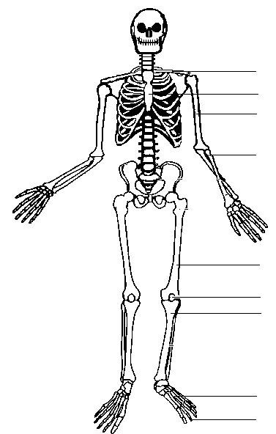

Question 24 (5 marks)

Label the muscles on the diagram below.
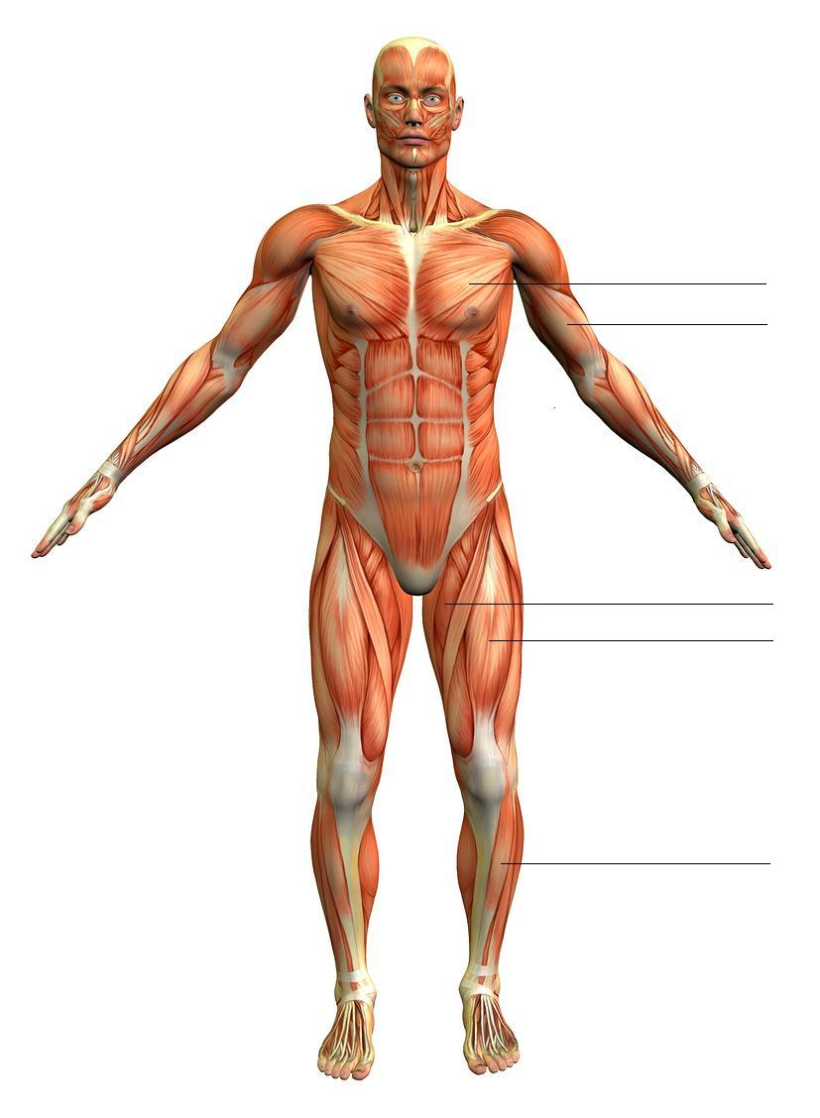

Question 25 (5 marks)

Label the muscles on the diagram below.

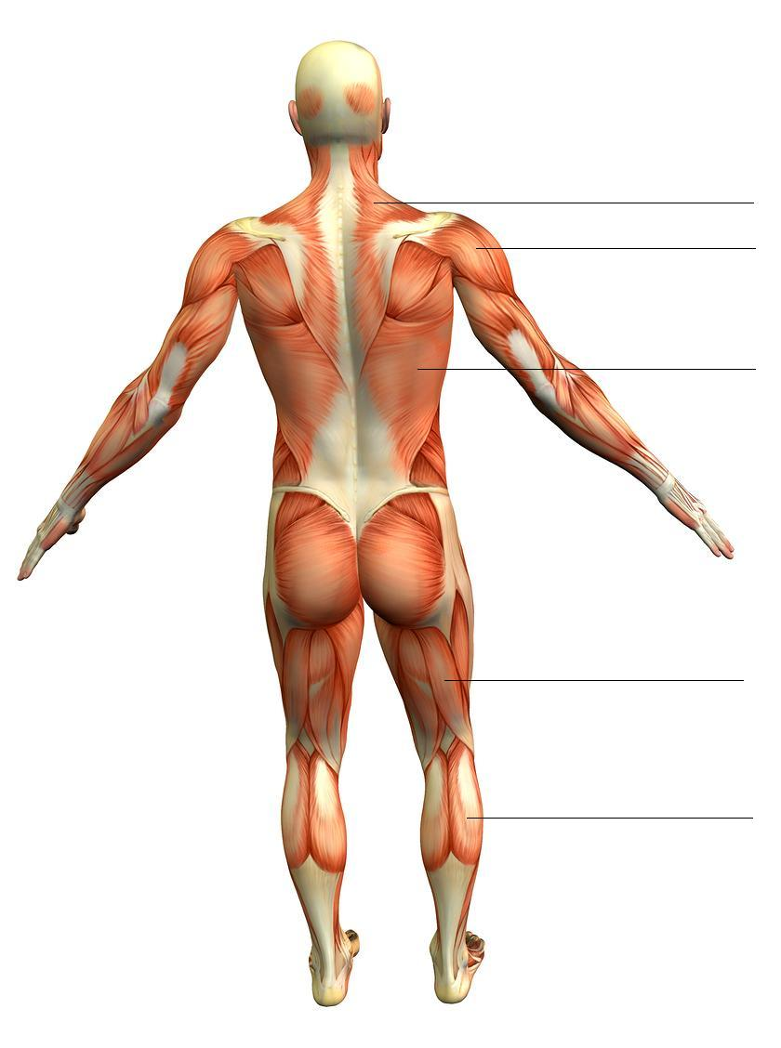

Question 26 (4 marks)

Identify and briefly explain the different factors that make gas exchange in the lungs possible. _______________________________________________________________________________________________________________________________________________________________________________________________________________________________________________________________________________________________________
___________________________________________________________
______________________________________________________________________________________________________________________
___________________________________________________________
______________________________________________________________________________________________________________________
___________________________________________________________

Question 27 (5 marks)

- Label the 2 blood vessels on the diagram below. (2 marks)

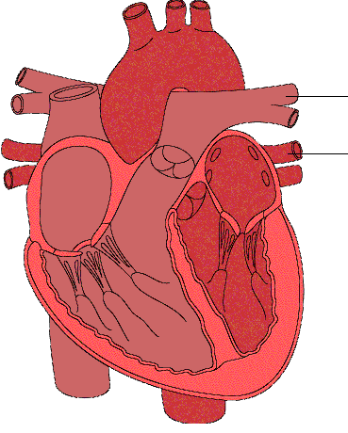

- State the function of each blood vessel. (3 marks)
_______________________________________________________________________________________________________________________________________________________________________________________________________________________________________________________________________________________________________
______________________________________________________________________________________________________________________
___________________________________________________________

Question 28 (4 marks)

List the 4 primary components of blood.
_____________________
_____________________
_____________________
_____________________

END OF SECTION TWO

This page has been deliberately left blank

Turn over the page for Section Three: Extended Answer

SECTION THREE: EXTENDED ANSWER (30 MARKS)

This section has four (4) questions. You must answer two (2) questions.
Write your answers in the spaces provided.

Spare pages are included at the end of this booklet. They can be used for planning your
responses and/or as additional space if required to continue an answer.
- Planning: If you use the spare pages for planning, indicate this clearly at the top of the page.
- Continuing an answer: If you need to use the space to continue an answer, indicate in the
original answer space where the answer is continued, i.e. give the page number. Fill in the
number of the question(s) that you are continuing to answer at the top of the page.

Suggested working time: 45 minutes.

Question 29 (15 marks)

The pre-season training program outlined below has been designed to prepare a team sport (e.g. soccer, netball, football) player for the start of a new season. No other training sessions have been prescribed for the player in addition to those outlined in the program below. Use the data in the training program below to answer the questions that follow.

 | Sun | Mon | Tues | Wed | Thur | Fri | Sat
Week 1 |  | 10 min jog |  | 10 min cycle |  | 10 min swim | 10 min jog
Week 2 |  | 11 min jog |  | 11 min cycle |  | 11 min swim | 11 min jog
Week 3 |  | 20 min jog |  | 20 min cycle |  | 20 min swim | 20 min jog
Week 4 |  | 22 min jog |  | 22 min cycle |  | 22 min swim | 22 min jog

- Explain why the pre-season training program is inadequate in terms of the principles of training that have not been correctly applied in the program. (6 marks)
________________________________________________________________________________________________________________________________________________________________________________________________________________________________________________________________________________________________________________________________________________________________________________________________________________________________________________________________________________________
_________________________________________________________________________________________________________________________________________________________________________________
_________________________________________________________________________________________________________________________________________________________________________________
________________________________________________________________________________________________________________________________________________________________________________________________________________________________________________________________________________________________________________________________________________________________________________________________________________________________________________________________________________________

- Identify 3 training types that have not been used in the program that a pre-season team sport program should include. Explain why these training types should be incorporated into the program. (9 marks)
________________________________________________________________________________________________________________________________________________________________________________________________________________________________________________________________________________________________________________________________________________________________________________________________________________________________________________________________________________________
_________________________________________________________________________________________________________________________________________________________________________________
_________________________________________________________________________________________________________________________________________________________________________________
________________________________________________________________________________________________________________________________________________________________________________________________________________________________________________________________________________________________________________________________________________________________________________________________________________________________________________________________________________________
_________________________________________________________________________________________________________________________________________________________________________________
_________________________________________________________________________________________________________________________________________________________________________________
_______________________________________________________________________________________________________________________________________________________________________________________________________________________________________________________________________________________________________

Question 30 (15 marks)

The fitness required to be an elite endurance athlete such as a marathon runner is developed over many years of training.

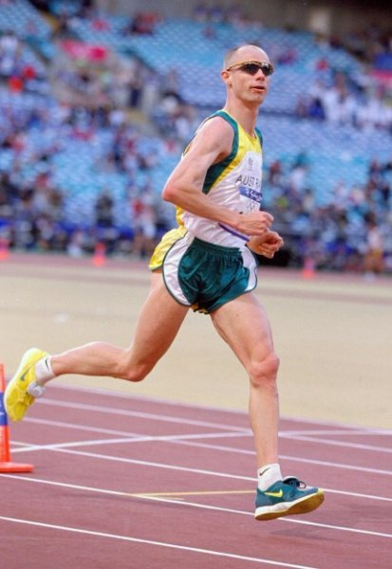

- Identify and describe 5 important long term adaptations to training for marathon runners and explain how these adaptations will enhance performance. (7 marks)
________________________________________________________________________________________________________________________________________________________________________________________________________________________________________________________________________________________________________________________________________________________________________________________________________________________________________________________________________________________
_________________________________________________________________________________________________________________________________________________________________________________
_________________________________________________________________________________________________________________________________________________________________________________
________________________________________________________________________________________________________________________________________________________________________________________________________________________________________________________________________________________________________________________________________________________________________________________________________________________________________________________________________________________
_________________________________________________________________________________________________________________________________________________________________________________
_________________________________________________________________________________________________________________________________________________________________________________

- Describe the types of training that would be used and the principles of training that would be applied in a training program for a marathon runner. Provide a reason for each of your answers. (8 marks)
________________________________________________________________________________________________________________________________________________________________________________________________________________________________________________________________________________________________________________________________________________________________________________________________________________________________________________________________________________________
_________________________________________________________________________________________________________________________________________________________________________________
_________________________________________________________________________________________________________________________________________________________________________________
________________________________________________________________________________________________________________________________________________________________________________________________________________________________________________________________________________________________________________________________________________________________________________________________________________________________________________________________________________________
_________________________________________________________________________________________________________________________________________________________________________________
_________________________________________________________________________________________________________________________________________________________________________________
________________________________________________________________________________________________________________________________________________________________________________________________________________________________________________________________________________________________________________________________________________________________________________________________________________________________________________________________________________________

Question 31 (15 marks)

The energy system and components of fitness requirements within a particular sport can alter depending on the different demands of different playing positions.

Select a sport that you are familiar with and, using examples, discuss how and why the energy system and components of fitness requirements are different for two different playing positions within that sport. Include in your answer a description of the two different playing positions.

________________________________________________________________________________________________________________________________________________________________________________________________________________________________________________________________________________________________________________________________________________________________________________________________________________________________________________________________________________________
_________________________________________________________________________________________________________________________________________________________________________________
_________________________________________________________________________________________________________________________________________________________________________________
________________________________________________________________________________________________________________________________________________________________________________________________________________________________________________________________________________________________________________________________________________________________________________________________________________________________________________________________________________________
_________________________________________________________________________________________________________________________________________________________________________________
_________________________________________________________________________________________________________________________________________________________________________________
________________________________________________________________________________________________________________________________________________________________________________________________________________________________________________________________________________________________________________________________________________________________________________________________________________________________________________________________________________________
_________________________________________________________________________________________________________________________________________________________________________________
_________________________________________________________________________________________________________________________________________________________________________________
________________________________________________________________________________________________________________________________________________________________________________________________________________________________________________________________________________________________________________________________________________________________________________________________________________________________________________________________________________________
_________________________________________________________________________________________________________________________________________________________________________________
_________________________________________________________________________________________________________________________________________________________________________________
________________________________________________________________________________________________________________________________________________________________________________________________________________________________________________________________________________________________________________________________________________________________________________________________________________________________________________________________________________________
_________________________________________________________________________________________________________________________________________________________________________________
_________________________________________________________________________________________________________________________________________________________________________________
________________________________________________________________________________________________________________________________________________________________________________________________________________________________________________________________________________________________________________________________________________________________________________________________________________________________________________________________________________________
___________________________________________________________

Question 32 (15 marks)

Explain the different reasons why it is unlikely that an Olympic 100m sprint champion would be competitive in an Olympic 10,000m race. Discuss reasons relating to anatomy, physiology and training in your explanation.

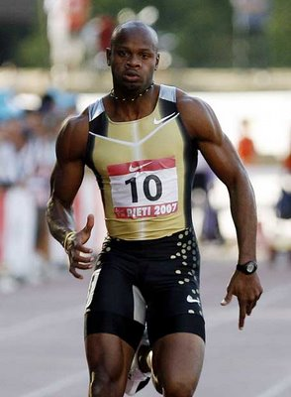  100m Sprinter | 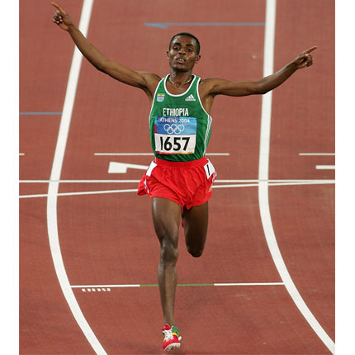  10,000m Runner

________________________________________________________________________________________________________________________________________________________________________________________________________________________________________________________________________________________________________________________________________________________________________________________________________________________________________________________________________________________
_________________________________________________________________________________________________________________________________________________________________________________
_________________________________________________________________________________________________________________________________________________________________________________
________________________________________________________________________________________________________________________________________________________________________________________________________________________________________________________________________________________________________________________________________________________________________________________________________________________________________________________________________________________
_________________________________________________________________________________________________________________________________________________________________________________
_________________________________________________________________________________________________________________________________________________________________________________
________________________________________________________________________________________________________________________________________________________________________________________________________________________________________________________________________________________________________________________________________________________________________________________________________________________________________________________________________________________
_________________________________________________________________________________________________________________________________________________________________________________
_________________________________________________________________________________________________________________________________________________________________________________
________________________________________________________________________________________________________________________________________________________________________________________________________________________________________________________________________________________________________________________________________________________________________________________________________________________________________________________________________________________
_________________________________________________________________________________________________________________________________________________________________________________
_________________________________________________________________________________________________________________________________________________________________________________
____________________________________________________________________________________________________________________________________________________________________________________________________________________________________________

End of Questions

Spare answer page. Clearly identify the question number that you are continuing.
____________________________________________________________________________________________________________________________________________________________________________________________________________________________________________
_________________________________________________________________________________________________________________________________________________________________________________
_________________________________________________________________________________________________________________________________________________________________________________
_________________________________________________________________________________________________________________________________________________________________________________
_________________________________________________________________________________________________________________________________________________________________________________
_________________________________________________________________________________________________________________________________________________________________________________
_________________________________________________________________________________________________________________________________________________________________________________
_________________________________________________________________________________________________________________________________________________________________________________
_________________________________________________________________________________________________________________________________________________________________________________
_________________________________________________________________________________________________________________________________________________________________________________
_________________________________________________________________________________________________________________________________________________________________________________
_________________________________________________________________________________________________________________________________________________________________________________
_________________________________________________________________________________________________________________________________________________________________________________
_________________________________________________________________________________________________________________________________________________________________________________
______________________________________________________________________________________________________________________
____________________________________________________________________________________________________________________________________________________________________________________________________________________________________________
_________________________________________________________________________________________________________________________________________________________________________________
_________________________________________________________________________________________________________________________________________________________________________________
_________________________________________________________________________________________________________________________________________________________________________________
_________________________________________________________________________________________________________________________________________________________________________________
_________________________________________________________________________________________________________________________________________________________________________________
_________________________________________________________________________________________________________________________________________________________________________________
_________________________________________________________________________________________________________________________________________________________________________________
_________________________________________________________________________________________________________________________________________________________________________________
_________________________________________________________________________________________________________________________________________________________________________________
_________________________________________________________________________________________________________________________________________________________________________________
_________________________________________________________________________________________________________________________________________________________________________________
_________________________________________________________________________________________________________________________________________________________________________________

This blank space has been provided for additional workings.

Marking Key

SECTION ONE: MULTIPLE CHOICE (20 marks)

Question Number | Correct Answer
1. | b
2. | c
3. | d
4. | a
5. | d
6. | d
7. | d
8. | b
9. | d
10. | b
11. | c
12. | b
13. | a
14. | a
15. | d
16. | c
17. | c
18. | a
19. | b
20. | d

SECTION TWO: SHORT ANSWER (50 MARKS)

Question 21 (12 marks)

The human body uses 3 Energy Systems to provide the energy needed to re-form ATP. Complete the following table to show the duration, fuel used and by-products of each system plus an example of an athletic event that primarily uses each system.

Energy System | Duration  1 mark | Fuel  1 mark | By-products  1 mark | Example  1 mark
ATP-CP | Up to 10 sec | Creatine phosphate | None | Acceptable answer i.e. 100m sprint
Lactic Acid | Up to 2 min | Glucose/  carbohydrates | Lactic acid | Acceptable answer i.e. 400m sprint
Aerobic | 2-3 hours | Carbohydrates, fats and protein | Carbon dioxide and water | Acceptable answer i.e. marathon

Question 22 (6 marks)

Using the quadriceps and hamstrings muscles as examples, explain how muscles work in pairs to produce coordinated movement.

 | 1 mark | 2 marks
Agonist/ antagonist relationship | One muscle moves a joint one way, the other muscle moves the joint in the opposite direction | As for 1 mark but uses correct terminology i.e. agonist/antagonist or prime mover/reciprocal muscle
Contract/relax | One muscle contracts whilst other muscle relaxes | As one muscle contracts the opposite muscle progressively relaxes or relaxes in a controlled manner
Quadriceps/ hamstrings | States that quadriceps and hamstrings work as a pair to produce movement at the hip or knee joint | Accurately explains quadriceps/hamstring movements at hip or knee joint i.e. quadriceps contract to extend knee whilst hamstrings relax, hamstrings contract to flex knee whilst quadriceps relax

Question 23 (9 marks)

Label the bones on the diagram below.

Question 24 (5 marks)

Label the muscles on the diagram below.

Question 25 (5 marks)

Label the muscles on the diagram below.

Question 26 (4 marks)

Identify and briefly explain the different factors that make gas exchange in the lungs possible.
 | 1 mark | 2 marks
Capillaries | States that gases can pass through capillaries | States that capillaries have walls of only one cell thickness
Diffusion process | States that gaseous exchange is possible due to pressure differences or similar | Uses the word diffusion and accurately explains the process i.e. gases move from areas of higher pressure to areas of lower pressure

Question 27 (5 marks)

- Label the 2 blood vessels on the diagram below. (2 marks)

 | 1 mark | 2 marks
Blood vessels | Pulmonary artery or pulmonary vein correctly identified | Pulmonary artery and pulmonary vein correctly identified

- State the function of each blood vessel. (3 marks)

 | 1 mark | 2 marks
Pulmonary artery | Take deoxygenated blood to the lungs or similar | Take deoxygenated blood to the lungs where CO₂ can be removed and O₂ picked up
Pulmonary vein | Take oxygenated blood back to the heart

Question 28 (4 marks)

List the 4 primary components of blood.

Plasma | 1 mark
Platelets | 1 mark
Red blood cells | 1 mark
White blood cells | 1 mark

SECTION THREE: EXTENDED ANSWER (30 MARKS)
There are four questions in this section. Attempt two questions.

Question 29 (15 marks)
The pre-season training program outlined below has been designed to prepare a team sport (e.g. soccer, netball, football) player for the start of a new season. No other training sessions have been prescribed for the player in addition to those outlined in the program below. Use the data in the training program below to answer the questions that follow.

- Explain why the pre-season training program is inadequate in terms of the principles of training that have not been correctly applied in the program. (6 marks)

 | 1 mark | 2 marks
Specificity | The training program does not adequately target the energy systems or components of fitness needed for a team sport player | The training program does not adequately target the energy systems and components of fitness needed for a team sport player
Progressive Overload | The progressive overload in week 3 increased by more than 10% or was too great | As for 1 mark and provides a reason why overload should not exceed 10% or be too great
Duration | Duration of training sessions is insufficient for producing long term adaptations needed for a team sport or duration of training sessions should be of a minimum of 30 minutes | Duration of training sessions is insufficient for producing long term adaptations needed for a team sport and duration of training sessions should be of a minimum of 30 minutes

- Identify 3 training types that have not been used in the program that a pre-season team sport program should include. Explain why these training types should be incorporated into the program. (9 marks)

Training types | 1 mark | 2 marks | 3 marks
Interval training | Training type identified | Explains that intervals more closely replicate requirements of the sport or that intervals allow for higher intensity exercise followed by recovery | Explains that intervals more closely replicate requirements of the sport and that intervals allow for higher intensity exercise followed by recovery
Resistance training | Training type identified | Explains that resistance training will assist in developing a component of fitness e.g. muscular strength, muscular endurance, power | Explains that resistance training will assist in developing 2 or more components of fitness e.g. muscular strength, muscular endurance, power, body composition
Flexibility training | Training type identified | Explains that flexibility training will increase range of motion/flexibility or assist in preventing injury | Explains that flexibility training will increase range of motion/flexibility and assist in preventing injury
Other training types e.g. circuit, fartlek, plyometrics | Training type identified | Satisfactory explanation of why training type could be included in program. Only two marks are available for these training types as they are not essential. Marks for these training types should only be used to allow up to 3 training types for the answer.

Question 30

The fitness required to be an elite endurance athlete such as a marathon runner is developed over many years of training.

- Identify and describe 5 important long term adaptations to training for marathon runners and explain how these adaptations will enhance performance.
(7 marks)
 | 1 mark | 2 marks
Long term adaptations | Relevant long term adaptation identified and accurately described e.g. increased cardiac output – the amount of blood pumped by the heart per minute.  1 mark per adaptation up to a maximum of 5 marks
Enhance performance | Accurate explanation of how 2 acceptable reasons e.g. increased oxygen carrying capacity, will enhance performance | Accurate explanation of how 3 or more acceptable reasons e.g. increased oxygen carrying capacity, will enhance performance

- Describe the types of training that would be used and the principles of training that would be applied in a training program for a marathon runner. Provide a reason for each of your answers.
(8 marks)
 | 1 mark | 2 marks | 3 marks | 4 marks
Types of training | 2 types of training described satisfactorily e.g. interval, fartlek, continuous training | 2 or more relevant types of training described and justified satisfactorily | 3 relevant types of training accurately described and justified | 4 relevant types of training accurately described and justified
Principles of training | 2 principles of training described satisfactorily e.g. specificity, progressive overload, intensity | 2 or more relevant principles of training described and justified satisfactorily | 3 relevant principles of training accurately described and justified | 4 relevant principles of training accurately described and justified

Question 31 (15 marks)

The energy system and components of fitness requirements within a particular sport can alter depending on the different demands of different playing positions.

Select a sport that you are familiar with and, using examples, discuss how and why the energy system and components of fitness requirements are different for two different playing positions within that sport. Include in your answer a description of the two different playing positions.

 | 1 mark | 2 marks | 3 marks | 4 marks
Selected sport | Valid sport chosen | As for one mark and selects 2 positions with contrasting requirements | As for 2 marks and accurately describes the two playing positions e.g. basketball centre positions themselves close to the basket for rebounds and close range scoring
Energy systems – why different | Satisfactorily discusses the reasons why the two positions have different energy system requirements | Accurately discusses the reasons why the two positions have different energy system requirements. Uses valid examples.
Energy systems – how different | Discusses at least two of the three energy systems i.e. ATP-CP, lactic acid and aerobic energy systems | Satisfactorily discusses different requirements of at least two energy systems for both positions | Accurately discusses requirements of all three energy systems for at least one of the positions | Accurately discusses requirements of all three energy systems for both positions
Components of fitness – why different | Satisfactorily discusses the reasons why the two positions have different components of fitness requirements | Accurately discusses the reasons why the two positions have different components of fitness requirements. Uses valid examples.
Components of fitness – how different | Discusses different requirements of at least one valid component of fitness for both positions | Satisfactorily discusses different requirements of at least two valid components of fitness for both positions | Accurately discusses different requirements of at least three components of fitness for both positions | Accurately discusses different requirements of four or more components of fitness for both positions

Question 32 (15 marks)

Explain the different reasons why it is unlikely that an Olympic 100m sprint champion would be competitive in an Olympic 10,000m race. Discuss reasons relating to anatomy, physiology and training in your explanation.

 | 1 mark | 2 marks | 3 marks
Muscle fibre types | The sprinter will have a very high percentage of fast twitch muscle fibres | As for 1 mark and also states that 10,000m runners require higher proportion of slow twitch muscle fibres | As for 2 marks and also explains a reason why e.g. fast twitch muscle fibres fatigue too quickly
Energy system requirements | The sprinter will have highly developed anaerobic energy systems or less developed aerobic energy system | As for 1 mark and also states that 10,000m runners require a more highly developed aerobic energy system or similar
Components of fitness | The sprinter will have great speed/power or too much muscle mass (body composition) | As for 1 mark and also states that 10,000m runners require more highly developed cardio-respiratory endurance | As for 2 marks but also discusses the different body composition e.g. sprinters have too much muscle mass
Principles of training | The sprinter has trained specifically for the 100m sprint or hasn’t trained specifically for the 10,000m | As for 1 and states the need to train specifically for an event in order to perform optimally in that event or similar
Long term adaptations | Identifies one long term adaptation to training for the sprinter that will hinder their ability in the 10,000m race e.g. muscle hypertrophy, increased anaerobic capacity or identifies one long term adaptation that a 10,000m runner needs e.g. larger increase in cardiac output, haemoglobin levels | Identifies one long term adaptation to training for the sprinter that will hinder their ability in the 10,000m race e.g. muscle hypertrophy, increased anaerobic capacity and identifies two or more long term adaptations that a 10,000m runner needs e.g. larger increase in cardiac output, haemoglobin levels
Training types | States that the training types used by the sprinter will not have prepared him/her for a 10,000m race or that a 10,000m runner needs to use different training types than a sprinter | As for 1 mark and accurately identifies one training type e.g. sprinter uses more interval (short)/ plyometrics training, 10,000m runner uses more continuous/fartlek training | States that the training types used by the sprinter will not have prepared him/her for a 10,000m race and that a 10,000m runner needs to use different training types than a sprinter. Accurately identifies a training type for each runner.

